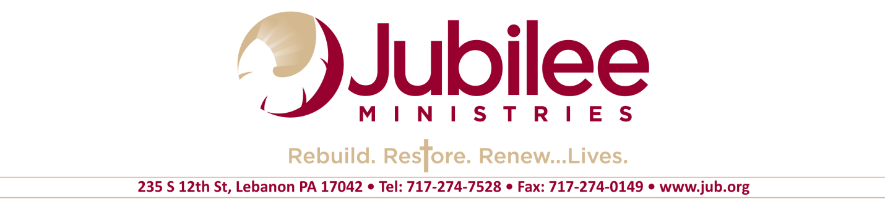
JOB OPPORTUNITY

​
Prison Chaplain

Status: Full Time / Exempt

Schedule: Variable Schedule That Includes Weekends
Location: SCI Mahanoy

- Do you have a heart for those living behind prison bars?

- Are you called to pastor a prison church?

- Can you lead group discussions on addictions, provide Biblical counseling, coach in life skills, and teach the Word of God?

- We are looking for an individual who is solid in the Christian faith, able to lead a worship service, and comfortable ministering in a prison environment.

All applicants must be willing to adhere to
Jubilee's Statement of Beliefs and Core Values.

Please complete an application at our stores or online at: www.jub.org/employment
and forward it with your resume to HR@jub.org
If you have inquiries concerning employment, you may also email HR@jub.org.

